External Debt and Currency Crisis in Emerging Markets

New Group Project

April 29, 2019

<https://github.com/TingjieMeng/New-Group-Project>

# Problem Statement

Debts and credits are crucial both for the expansion of businesses and for economic development. However, when the growth of debts outpaces the growth of income, debts become a time bomb triggering crises. There are two types of debts: domestic debts denominated in the domestic currency and external debts denominated in foreign currencies. The history of financial crises tells us that countries with a high level of external debt are especially vulnerable to capital outflows and thus exchange rate fluctuations. As Ray Dalio describes, such an event is called an inflationary depression.

Classic examples of a deflationary depression are the Tukish currency crises in the early 2000s and 2018. Since the 1980s, Turkey has been heavily dependent on foreign investments to fund its huge current account deficits, especially in the capital-intensive construction sector. Thus its economy is fragile to any internal or external shock that can lead to foreign capital outflow on a large scale. In 2001, foreign investors quickly withdrew capital from Turkey amid political tensions and tightening fiscal policies by the Turkish government, which caused the value of Turkish lira to plunge. The history repeats itself. In 2018, due to domestic instability and tightening monetary policies from major central banks, Turkey saw a year-over-year decline of foreign investments by 9,500 basis points. Without sufficient foreign capital to support its weak economy, the Turkish lira soon began drastically losing value, leaving many companies unable to serve their foreign currency debts.

Our project focuses on studying the link between external debt and currency crisis in Emerging Market Economies (EME). As shown in Turkey’s crises, over-dependence on external financing can be extremely dangerous for EMEs in the long run. However, EMEs typically face difficulties in issuing debts in local currency because their local financial markets are underdeveloped. Thus they are more likely to hold a significant portion of external debt in the total debt portfolio compared to developed economies. Specifically, we explore factors that strengthen or weaken the link between external debt and currency crisis in EMEs and use the patterns we find to predict the possibility of a currency crisis happening in future years. Our findings can serve as policy guidance for external debt management for central bank policymakers in emerging markets.

# Research Design

## testable hypothesis

Our main hypothesis that countries who have borrowed excessively in foreign currency are more prone to currency crisis risks. Sufficient foreign reserves, a stable political regime, and a strong economy make countries more resilient against currency depreciation risks. Currency crises are more likely to happen when the U.S. Federal Reserve increases the interst rate because that creates more incentives for investors to bring money from EMEs back into the United States.

## dataset

A set of time series data covering 44 developing countries from 1990 to 2015

## data source

Data sources for this study are as follows: the World Bank Open Data, the International Monetary Fund (IMF) Open Data, and the Polity IV Project conducted by the Center for Systemic Peace. All three data sources are publicly available. The World Bank and IMF APIs can be installed in R, and the Polity IV Project data can be conveniently downloaded as a csv package.

## variable description

Dependent variable: possibility of a currency crisis happening, defined as a nominal depreciation of 15% within a year Independent variable of interest: externaldebt/GNI Control variable: GDP per capita, level of democracy, US 3-month treasury yield, foreign reserves/total external debt

# Methods

## data visualization

Data visualization is used for getting a general understanding of the relationships between independent variables and dependent variables. It is also used as case studies of individual countries that experience a classic pattern of currency crises. Here we selected nine typical EMEs from Asia, South America, Africa and Europe (China, Brazil, Romania, Russia, Sierra Lenone, Thailand, Turkey, Ukraine and South Africa) as case studies to explore how external debt level,polity score, U.S. interest rate, and foreign reserves are associated with the incidence of currency crisis in EMEs.

Figure 1 shows the external debt/GNI by countries in different years, with red dots as when currency crisis happened. From this figure, we can see for Thailand and Sierra Leone, the incidence of currency crisis appears to be correlated with high external debt/GNI levels. But for other countries, such a correlation is not very obvious. 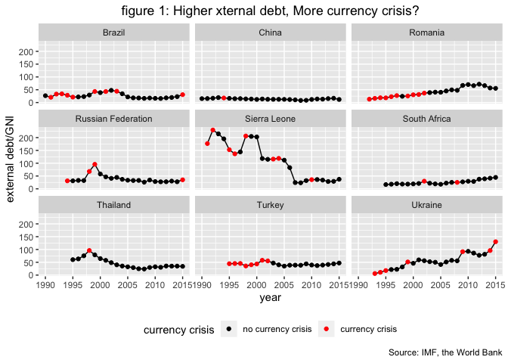

Figure 2 presents how U.S. interest rate as an external factor associated with the currency crisis. The line graph shows the change of U.S. interest rate across years, and the bar chart calculates the number of countries which undergone currency crisis in each year, based on all countries in the dataset (not only the nine countries we selected). The trend of U.S. interest rate and the number of countries undergoing currency crisis appear to move in similar direction.

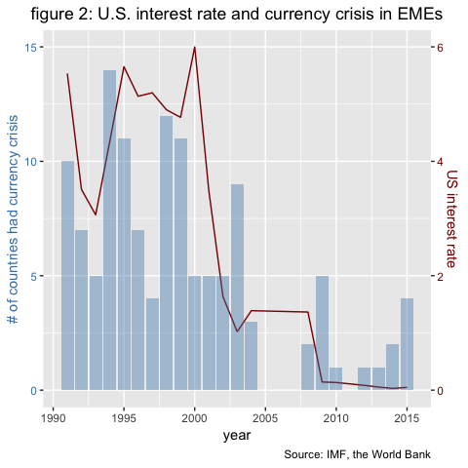

Figure 3 visualizes the correlation between foreign reserves and currency crisis based on the nine countries we previously selected. The line graph shows the foreign reserves out of total external debt of each nine countries across years, with red dots indicating the year of currency crisis happened. For China, Thailand, Ukraine, the correlation between low foreign reserves out of external debt and incidence of currency crisis seems to be strong.

Figure 4 and figure 5 examines the factor of polity score. Figure 4 shows that polity score might not necessarily correlate with currency crisis, especailly for China, Brazil, South Africa, Turkey and Thailand. The correlation between olity score and GDP per capita (another control variable) also seems to be weak. One explanation is that the polity score might be not a perfect proxy for political stability.

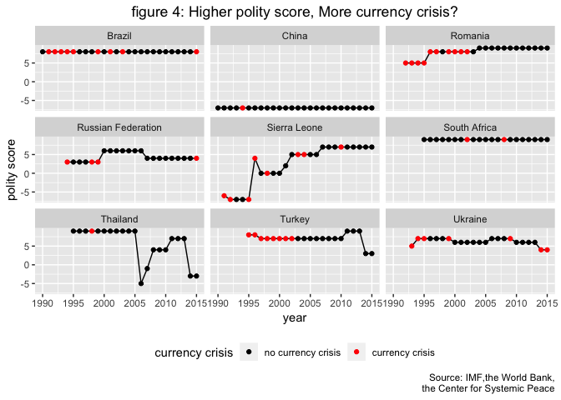

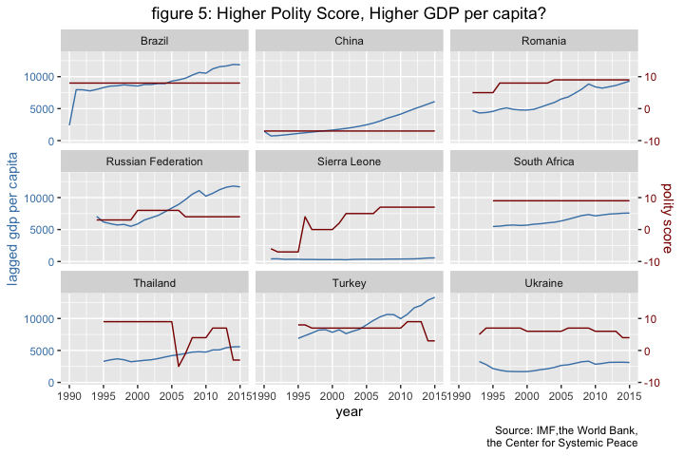 ## mixed-effect logit model

The logit model in parameterization form is as follows. It is used for modelling the probability of a currency crisis happening given all variables.

The logit model shows that there is a positive correlation between our independent variable of interest and the dependent variable, and such correlation is statistically significant at the 0.1% level. This supports our main hypothesis that countries who have borrowed excessively in foreign currency are more prone to currency crisis risks. In terms of control variables, the model shows a negative correlation between the ratio of foreign reserves to a country’s total external debt in the previous year and the dependent variable. There is also a negative correlation between GDP per capita in the previous year and the probability of a currency crisis happening. However, the correlations for both these two control variables are not statistically significant. There is a positive correlation between US 3-month treasury yield and the dependent variable, but again this correlation is not significant. Generally, our finding is consistent with our theory, that countries with stronger economies (higher GDP per capita) and sufficient foreign reserves are more resilient against currency crises. Besides, in terms of external factors, currency risks are particularly high during times when the US Federal Reserve sets the interest rate high.  
In our hypothesis, countries which have higher polity scores typically have more transparent and efficient public management systems. That enables those countries to deal with exchange rate problems more effectively. However, the positive coefficient for polity score shown here is in contrast with our expectation. This is most likely due to the dataset issue, that the polity score is not the best indicator for level of democracy. Countries like China and Brazil have low polity scores but have stable exchange rates. There is no good equivalent to R-squared for logistic regression models. One alternative is to look at the log likelihood, which is -306.2 in this case. Another alternative is to look at the AIC, which is 628.4 here. Both the log likelihood and AIC are relative measures of model fit. A lower value of the AIC or higher value of log likelihood suggests a relatively “better” model.

Figure 6 presents the partial dependency plots of all the independent variables. 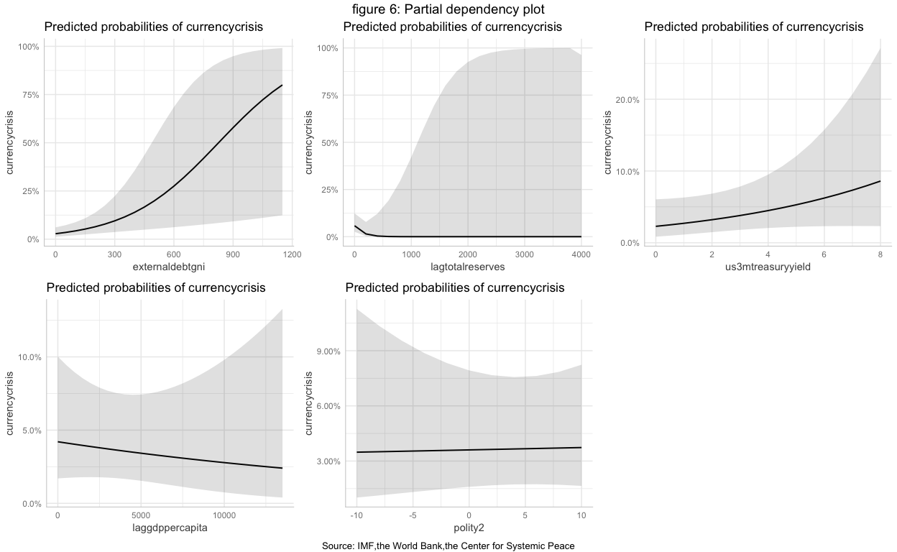

## Machine learning

Machine learning here is used for the purpose of classification. We split the data into a training and test dataset, partitioning data before 2014 into the training data, and holding out data in and after 2014 as a test set. We use three models, KNN, CART, and Random Forest. After compare the ROC of all three models using a dot plot, we find the random forest model has the higest sensitivity. We test the out-of-sample predictive performance for the best performing model, which is mod2_rf and use a table to visualize the predictive capability. For the Random Forest model, three most important variables are external debt to gni, lagged gdp per capita, and lagged total reserves.

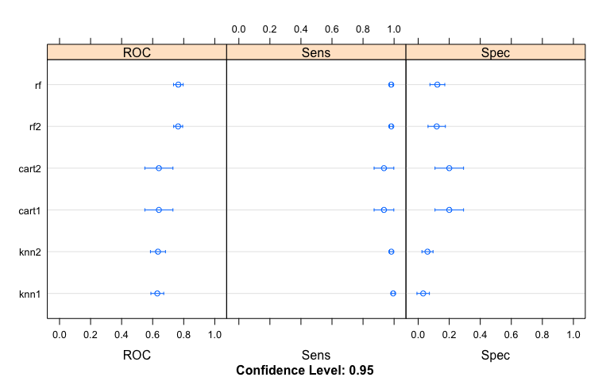

Confusion Matrix and Statistics

pred no yes no 82 6 yes 0 0

Accuracy : 0.9318   
 95% CI : (0.8575, 0.9746)  
No Information Rate : 0.9318   
P-Value [Acc > NIR] : 0.60637   
   
 Kappa : 0

Mcnemar’s Test P-Value : 0.04123

Sensitivity : 1.0000   
 Specificity : 0.0000   
 Pos Pred Value : 0.9318   
 Neg Pred Value : NaN   
 Prevalence : 0.9318   
 Detection Rate : 0.9318

Detection Prevalence : 1.0000  
Balanced Accuracy : 0.5000

'Positive' Class : no

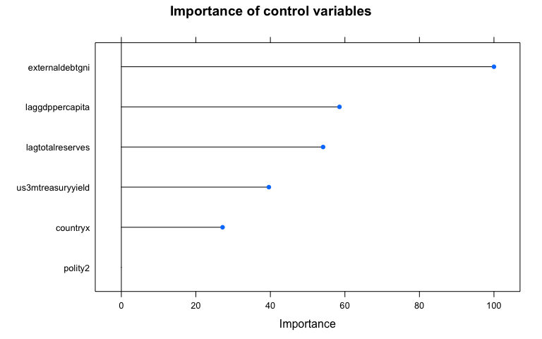

# Conclusion

## Lessons Learned

The first and most straightforward policy implication is that countries should be cautious about their level of external debt, especially emerging market economies (EME). Secondly, EMEs can take multiple measures to increase thier resilience against currency crises.Those include stocking foreign reserves, maintaining the credibility of central banks in the international capital market, and developing a strong economy. The third policy implication is that currency crisis risks are particularly high in times of Fed rate hikes. This reminds policymakers from national central banks and international organizations like the IMF that EMEs’ external debts need to be more closely monitored in times of interest rate volatility.

## Next steps

First, as mentioned in the results analysis part, polity score published by Center for Systemic Peace measures the level of democracy, not the political regime stability. That introduces bias into our model. Besides, potentially there can be more variables to be included in the model, like the economic structure and exchange rate regime. Third, our dataset only includes data until 2015, which means that currency crises in Turkey and Argentina in 2018 are not in our sample. In future research, it will be meaningful to see if our findings remain the same when a larger sample is used.

# Appendix

## Logit Regression

The main logit regression result is as follows.

##   
## ======================================  
## Model 1   
## --------------------------------------  
## (Intercept) -3.41 ***  
## (0.69)   
## laggdppercapita -0.00   
## (0.00)   
## lagtotalreserves -0.01   
## (0.01)   
## externaldebtgni 0.00 **   
## (0.00)   
## polity2 0.00   
## (0.03)   
## us3mtreasuryyield 0.17   
## (0.11)   
## --------------------------------------  
## AIC 628.35   
## BIC 667.95   
## Log Likelihood -306.18   
## Num. obs. 1043   
## Num. groups: countryx 44   
## Num. groups: year 26   
## Var: countryx (Intercept) 1.91   
## Var: year (Intercept) 1.11   
## ======================================  
## *** p < 0.001, ** p < 0.01, * p < 0.05

We changed model specifications and to see if the results will change as we drop control variables gradually.

##   
## ======================================  
## Model 1   
## --------------------------------------  
## (Intercept) -3.57 ***  
## (0.62)   
## lagtotalreserves -0.01   
## (0.01)   
## externaldebtgni 0.00 **   
## (0.00)   
## polity2 0.00   
## (0.03)   
## us3mtreasuryyield 0.18   
## (0.11)   
## --------------------------------------  
## AIC 626.63   
## BIC 661.28   
## Log Likelihood -306.32   
## Num. obs. 1043   
## Num. groups: countryx 44   
## Num. groups: year 26   
## Var: countryx (Intercept) 1.82   
## Var: year (Intercept) 1.15   
## ======================================  
## *** p < 0.001, ** p < 0.01, * p < 0.05

##   
## ======================================  
## Model 1   
## --------------------------------------  
## (Intercept) -4.02 ***  
## (0.59)   
## externaldebtgni 0.00 **   
## (0.00)   
## polity2 0.00   
## (0.03)   
## us3mtreasuryyield 0.21   
## (0.12)   
## --------------------------------------  
## AIC 628.09   
## BIC 657.79   
## Log Likelihood -308.05   
## Num. obs. 1043   
## Num. groups: countryx 44   
## Num. groups: year 26   
## Var: countryx (Intercept) 1.96   
## Var: year (Intercept) 1.41   
## ======================================  
## *** p < 0.001, ** p < 0.01, * p < 0.05

##   
## ======================================  
## Model 1   
## --------------------------------------  
## (Intercept) -4.01 ***  
## (0.55)   
## externaldebtgni 0.00 **   
## (0.00)   
## us3mtreasuryyield 0.21   
## (0.12)   
## --------------------------------------  
## AIC 626.10   
## BIC 650.85   
## Log Likelihood -308.05   
## Num. obs. 1043   
## Num. groups: countryx 44   
## Num. groups: year 26   
## Var: countryx (Intercept) 1.96   
## Var: year (Intercept) 1.41   
## ======================================  
## *** p < 0.001, ** p < 0.01, * p < 0.05

##   
## ======================================  
## Model 1   
## --------------------------------------  
## (Intercept) -3.43 ***  
## (0.43)   
## externaldebtgni 0.00 **   
## (0.00)   
## --------------------------------------  
## AIC 626.88   
## BIC 646.68   
## Log Likelihood -309.44   
## Num. obs. 1043   
## Num. groups: countryx 44   
## Num. groups: year 26   
## Var: countryx (Intercept) 1.98   
## Var: year (Intercept) 1.79   
## ======================================  
## *** p < 0.001, ** p < 0.01, * p < 0.05

## Machine Learning

Confusion matrix for the Random Forest model

## Confusion Matrix and Statistics  
##   
##   
## pred no yes  
## no 82 6  
## yes 0 0  
##   
## Accuracy : 0.9318   
## 95% CI : (0.8575, 0.9746)  
## No Information Rate : 0.9318   
## P-Value [Acc > NIR] : 0.60637   
##   
## Kappa : 0   
##   
## Mcnemar's Test P-Value : 0.04123   
##   
## Sensitivity : 1.0000   
## Specificity : 0.0000   
## Pos Pred Value : 0.9318   
## Neg Pred Value : NaN   
## Prevalence : 0.9318   
## Detection Rate : 0.9318   
## Detection Prevalence : 1.0000   
## Balanced Accuracy : 0.5000   
##   
## 'Positive' Class : no   
##